Software Requirements Specification
for
<School Management Web Application >
Version 1.0 approved
Prepared by <Pattapu Sai vamsi,
Oleti Bhanu Prakash,
Peguda Likhitha,
Manchikanti Ravi teja
Modepally Sree Manasa>
<NIIT >
<24-9-2018>

Table of Contents
Table of Contents ii
Revision History ii
1. Introduction 1
1.1 Purpose 1
1.2 Document Conventions 1
1.3 Intended Audience and Reading Suggestions 1
1.4 Product Scope 1
1.5 References 1
2. Overall Description 2
2.1 Product Perspective 2
2.2 Product Functions 2
2.3 User Classes and Characteristics 2
2.4 Operating Environmen 2
2.5 Design and Implementation Constraints 2
2.6 User Documentation 2
2.7 Assumptions and Dependencies 3
3. External Interface Requirements 3
3.1 User Interfaces 3
3.2 Hardware Interfaces 3
3.3 Software Interfaces 3
3.4 Communications Interfaces 3
4. System Features 4

5. Other Nonfunctional Requirements 4
5.1 Performance Requirements 4
5.2 Safety Requirements 5
5.3 Security Requirements 5
5.4 Software Quality Attributes 5
5.5 Business Rules 5
6. Other Requirements 5
Appendix A: Glossary 5
Appendix B: Analysis Models 5
Appendix C: To Be Determined List 6

Revision History
Name | Date | Reason For Changes | Version

Introduction

Purpose
Main purpose of this project is to reduce the manual registering work in schools. This helps them to save lot of time which can be used for some other purposes.

Document Conventions
This document was based on SRS IEEE Template for Software Requirement Specifications.

Intended Audience and Reading Suggestions
- This is document is useful for students who are enrolled in the school using this software.
- This is also intended for developers who can further improve its functionalities.
- This document is useful for marketing people to promote the product.
- Rest of the SRS contains detailed information about application requirements and other usage details.
- We would like to suggest to go through one-by-one rather than skipping the topics in the middle.

Product Scope
This web application is a kind of tool for schools to enhance their working speed in reaching out to the students, teachers and parents.

References
Only reference to this document is the basic idea of the project and SRS IEEE Template for Software Requirement Specifications.

Overall Description

Product Perspective
This web application is useful to all the schools who want or trying to automate works and increase the speed for their daily needs so that everyone related to that school will get benefited. Lots and lots of manual physical work can be reduced. It will run on any browser connected to internet with a good speed.

Product Functions
There are many functions in this application. Few of them are listed below.
- Update Attendance: To update attendance of a students from a particular class.
- Open attendance: To see a particular student’s attendance.
- Update Examination Results: To upload or update results of an exam conducted.
- Update Spot light: To put something miracle happened in the school by students or teachers or any achievement by anyone.
- Open courses: Let’s students to see his courses for that year.
- Discussion: To participate in online discussion after school.
- Transport Details: Shows user about the recent changes in transport system.
- Online Course: It will be separate attribute where admins manages all the online courses in which no teacher is involved.
- Check for Appointment: This allows user to create an appointment with the school in-charge or Head master.
- Raise or check complaints: This allows user to raise complaint.
- Teachers Info: Provides teachers info to the students to contact them.
- Update details: This function shows the recently updated issues on the website.

User Classes and Characteristics
- Typical users are students who want to check their academic performance and class participation
- Teachers are one of the most important users of this application to update academic details of students and provide them with study material.
- School Management and Admin come under the same roof as the admin has to do whatever management tell.

Operating Environment
It works on any operating system with a browser in it and a good speed of internet.

Design and Implementation Constraints
This website is being developed in HTML, CSS for interface of the user and JAVA, MySQL to run in the back-end with eclipse as the platform to develop. Any of Java Frame works will be used whenever necessary.

User Documentation
There will be quick start guide to after the completion of project.

Assumptions and Dependencies
This web application requires flash player to run as there will be some kind of flash plays on the first page. Any operating system will be fine if connected to the internet.

External Interface Requirements

User Interfaces
TBD

Hardware Interfaces
Any web browser which can connect to the internet can access this website. Besides that, some basic requirements of a computer are needed.

Software Interfaces
Latest version of the browser will be appreciated to use this site.

Communications Interfaces
TBD.

System Features
This section demonstrated the website’s prominent features and explains how they can be used and results they will give back to the user.

  - Login
Users need to login first to do anything with the database or getting any kind of information. Users cannot create their own account: admin will generate account for each one’s purpose later on they can change their login passwords.\

    - Stimulus/Response:
After logging in with your username and password, you will be shown your profile. If you’re a student you will be shown a page where you can see all your grades, attendances and courses you are attending online. If you are a teacher, you will see the marking attendance button and uploading attendance or some course material. You will also be provided with the online discussion forum where you can talk with the students to clarify any doubts. All other things will be described below.

    - Functional Requirements:
Requirement ID 1: Legal User name
Requirement ID 2: Legal Password for your username
If anyone of the two is wrong, you will get an error message and will be prompted to retry if you can’t login after many trails you have to change your password by clicking forgot password button.

  - Student Info
There will be three users of this feature. They are Students, teachers, admin. Admin is basically the school management itself.
Students data will be provided to all three of them. Student data contains every single detail about the students enrolled in school for a particular class

4.2.1 Stimulus/Response:
This feature provides all the information provided by the student at the time of admission and allows all three users to make any kind of changes to it.

4.2.2 Functional Requirements:
Requirement ID 1: Login
Requirement ID 2: Students info must be uploaded in the database and given required permission to the users of that information.
If any of the above requirements are not satisfactory information is not retrieved for any kind of users.

  - Attendance Records
This feature contains all the details about attendance of students in each and every class on every day. Users of this are Students, Teachers and Admins.

    - Stimulus/Response:
Usage of this feature lets teachers update attendance of a specific class and students can monitor their attendance day to day and report if any discrepancies occur.

    - Functional Requirements:
Requirement ID 1: Students must be enrolled in that subject.
Requirement ID 2: Teacher must have access to that subject from admin.
Requirement ID 3: Time should be looked before uploading attendance.
Requirement ID 4: Teacher and student must login to their respective accounts.

  - Examination Info
Using this feature lets all the users to retrieve information about examinations conducted or going to conduct in the near future.

    - Stimulus/Response:
When a user uses this system feature, exam information will be provided to the user and let’s specified user to update or do any changes in the grades or something else.

    - Functional Requirements:
Requirement ID 1: User must be logged into his/her account.
Requirement ID 2: Must have registered for any online examinations.
Requirement ID 3: Teacher must have access to a particular subject to update grades of that subject.

  - Transport Details

    - Stimulus/Response:
Usage of this feature lets user to get to know about information recently updated changes in the transport system in the school. Online database will have updated with an instance of time so that whoever will access the site can see the details.

    - Functional Requirements:
There are no particular functional requirements for this. Whoever access the website that person get to know the changes occurred.

  - Online Discussion Forum
It provides a chat box for students and teachers to discuss any kind of issues they have.

    - Stimulus/Response:
Usage of this feature enables students and teachers to chat with all the users who are online at that moment. They can share photos, videos or any other media possibly available with them.

    - Functional Requirements:
Requirement ID 1: User must be logged into his/her account.
Requirement ID 2: Teacher with whom user want to discuss should also be logged in to
their account.

  - Self Learning Online Courses

    - Stimulus/Response:
In this students are provided some additional courses based on their interests for which teachers helps to resolve their doubts and these courses will not be taught in regular classes.

    - Functional requirements:
Requirement ID1: Student must be logged in to see his/her extra courses.

  - Online Appointment

    - Stimulus/Response:
with this a student can request for an appointment with any teacher.

    - Functional requirements:
Requirement ID1: Login is required.

  - Teacher leave Form

    - Stimulus/Response:
Teachers can generate an online request to put a leave and inform the management of the school well before their day of absence. This features sends a mail to admin head as soon as the form is submitted. Teacher will get confirmation by e-mail.

    - Functional Requirements:
Requirement ID1: Login is required.
Requirement ID2: Teacher must be registered in the database.

  - Complaint Form

    - Stimulus:
Any user can raise a complaint on the issues in school. These complaints will be directly sent to admin head and forwarded to the concerned department. And then they will take action on that and reply mail will be sent to the person who raised the complaint.

    - Functional Requirements:
Requirement ID1: Anyone who can access the webpage can raise a complaint by providing the valid details.
  - Spot Lights

    - Stimulus/Response:
This is basically like a school newspaper which contains the highlights in the school like birthdays, competition winners, events etc. Only admin and teachers can add spotlights.

    - Functional Requirements:
Requirement ID1: Teacher and admin must login to their respective accounts to put any kind of spotlight things.

  - Course View

    - Stimulus/Response:
In this a student can view reports of all his courses.

    - Functional Requirements:
Requirement ID1: Student must be logged in.
Requirement ID2: Student must be registered to the course for which he/she is trying to see report.

  - Add Teacher or Student

    - Stimulus/Response:
In this principal/Admin can add student or teacher. Added persons will be stored in the database and used further.

    - Functional Requirements:
Requirement ID1: Admin must be logged in.Only admin can do this.

  - Student Fee

    - Stimulus/Response:
In this all fee related information will be there. Students can see how much fee will be charged for all purposes.

    - Functional Requirements:
There are no special requirements student must be logged in to acces this feature.

4.15 Help

4.15.1 Stimulus/Response:
Contact details of all the departments of the school will be made available. These details will get updated if any changes made by administration.

4.15.2 System Requirements:
Requirement ID1: Anyone who can access the URL can find the details and get necessary help.

5.Other Nonfunctional Requirements

Performance Requirements
System should be connected to internet. Internet speed of 1 Mb/s would be appreciated to use. PC or Mobile can be used to access the website. 1 GHz processor speed is required to use this application.

Security Requirements
As this website can be accessed from any online device, only security requirement is that you open the correct URL to get rid of unnecessary logins.

Software Quality Attributes
TBD

Business Rules
TBD

6.Other Requirements
Appendix A: Glossary
TBD
Appendix B: Analysis Models
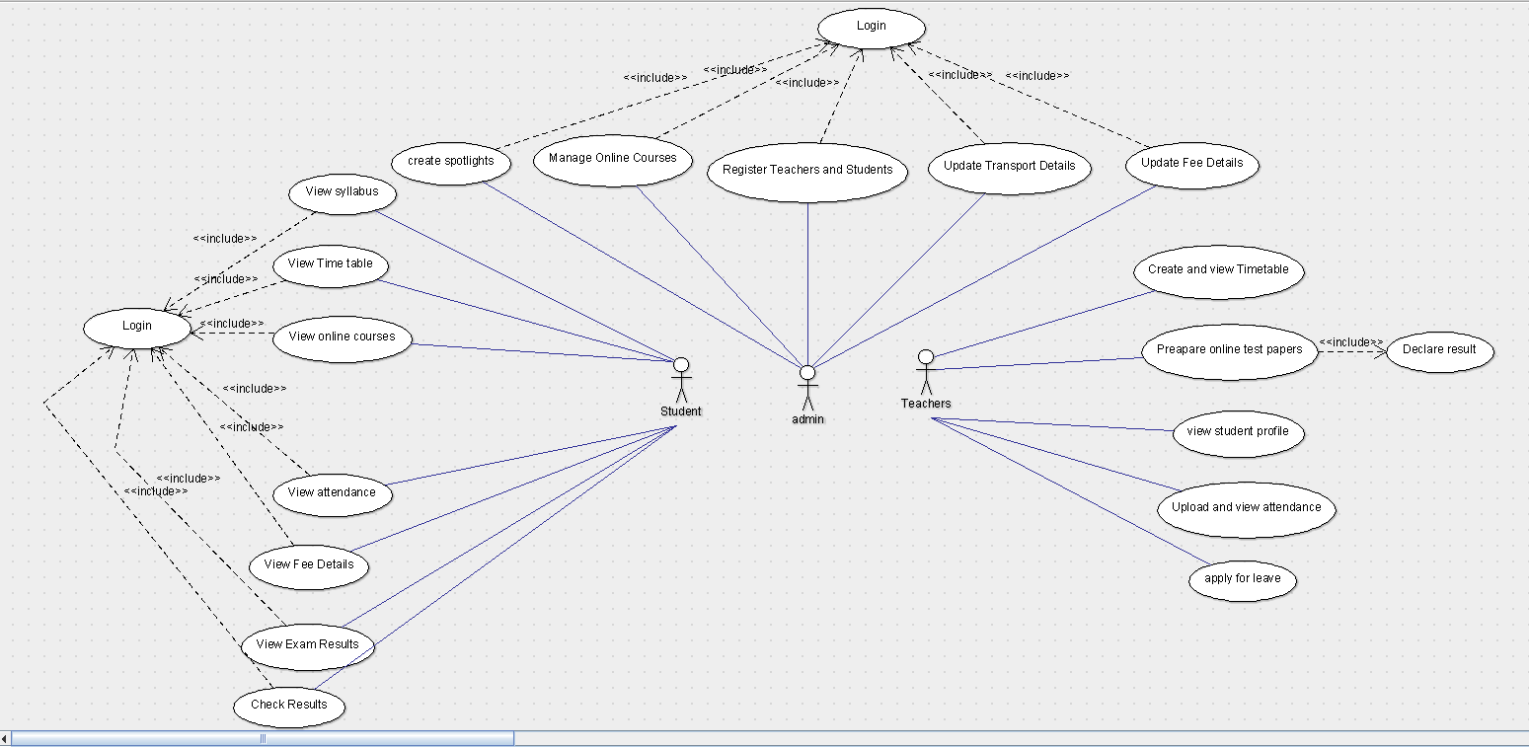

Appendix C: To Be Determined List
- To be determined list will increase in course of the project as per requirements and the obligations of the customer.
- Functional requirements will be added in course of the project.

